Test Case Overview | ID or Name | TC-1
Test Case Overview | Description | Login
Test Case Overview | Reporter | Ozomata and Godswill
Test Case Overview | Completion Date | 20th March 2023
Test Case Steps & Results | Test case steps | The User should be able to log in with a username and password
Test Case Steps & Results | Expected result | You should now be logged in to the dashboard.
Test Case Steps & Results | Actual result | The dash board displayed
Test Case Steps & Results | Status | Pass
Environment | URL | http://127.0.0.1:8000/dashboard/
Environment | Screenshot | 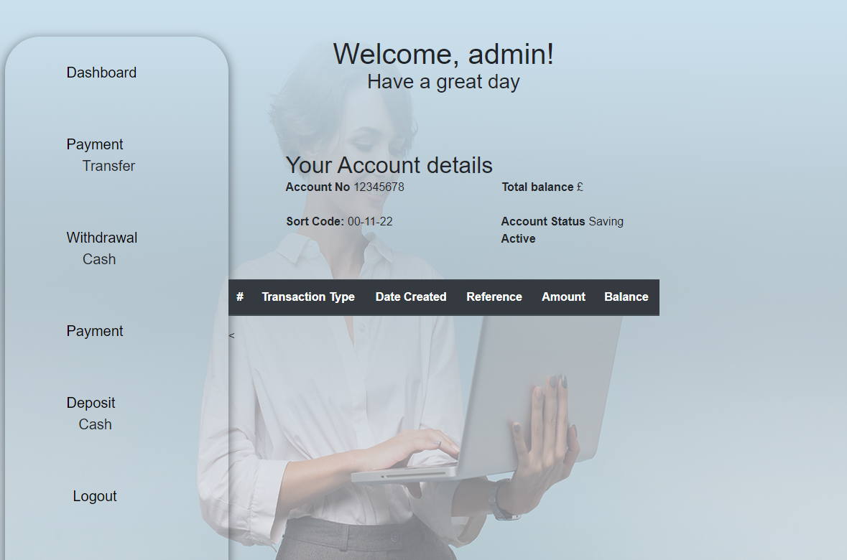
Environment | Operating System | Windows 10.0.0
Environment | Browser | Version 111.0.5563.111 (Official Build) (64-bit)
Notes | Notes

USER ACCEPTANCE TEST SIGNOFF

Tester | Client
Godswill Daudu | Ozomata Asun
 |   

Test Case Overview | ID or Name | TC-2
Test Case Overview | Transfer | Withdrawal and Deposit
Test Case Overview | Reporter | Ozomata and Godswill
Test Case Overview | Completion Date | 20th March 2023
Test Case Steps & Results | Test case and steps | The application should be able to allow the customer to withdraw cash from the account.  Select deposit funds/ or withdraw dunds  Choose Account to deposit  Input amount  Select submit
Test Case Steps & Results | Expected result | Dashboard shows the withdrawal / Deposit with new balance
Test Case Steps & Results | Actual result | The dash board displayed the deposit and withdrawal
Test Case Steps & Results | Status | Pass
Environment | URL | http://127.0.0.1:8000/dashboard/
Environment | Screenshot | 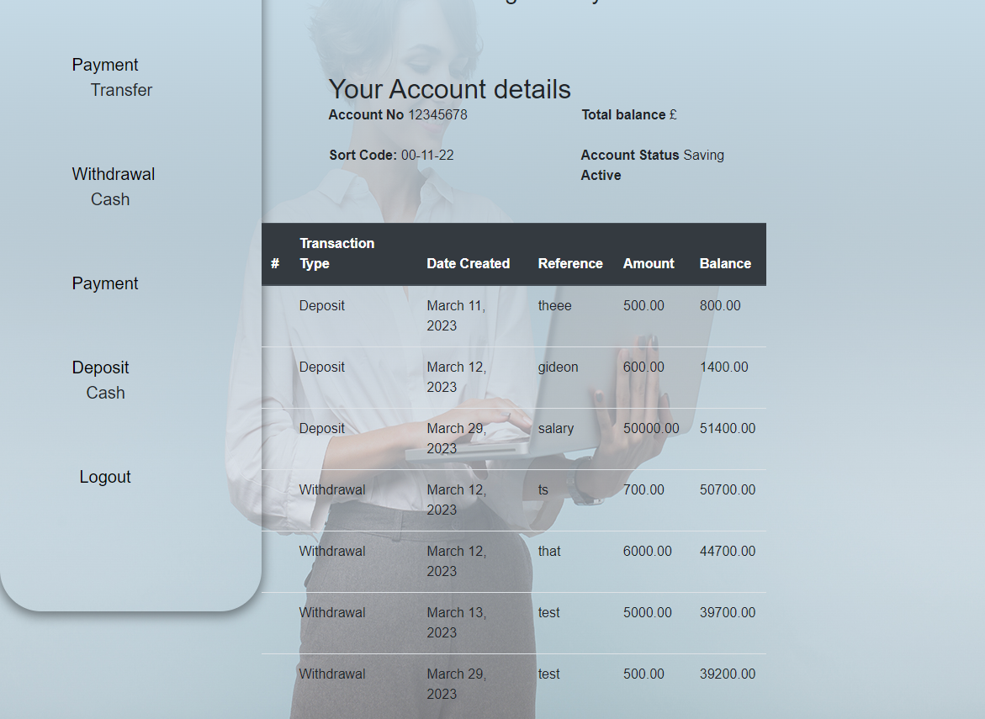
Environment | Operating System | Windows 10.0.0
Environment | Browser | Version 111.0.5563.111 (Official Build) (64-bit)
Notes | Notes
Tester | Client
Godswill Daudu | Ozomata Asun

